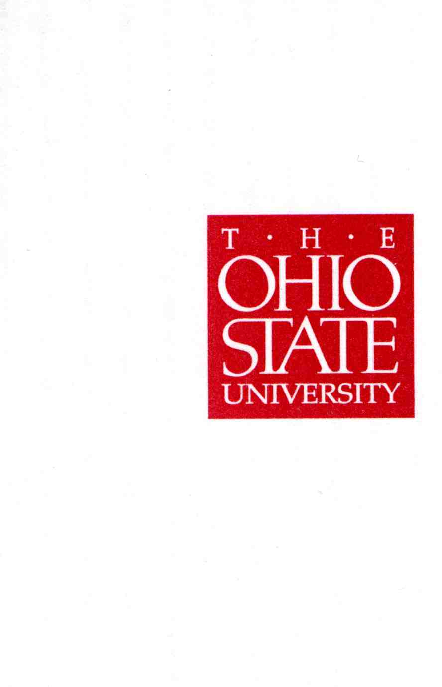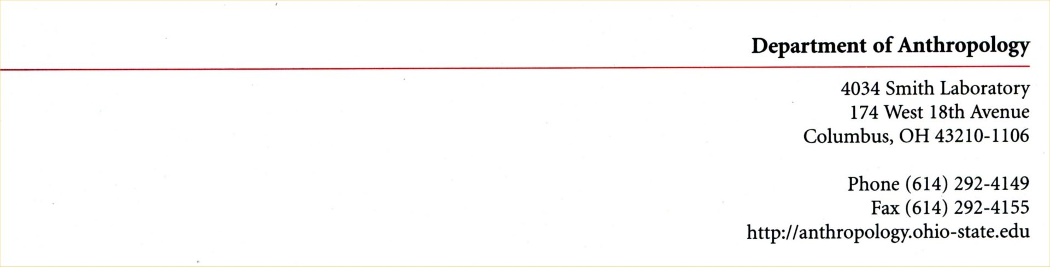

23 February 2017

Dr. Meg Daly, Chair
Arts and Sciences Curriculum Committee
College of Arts and Sciences
The Ohio State University

Re: Proposal for Major in Medical Anthropology

Dear Members of the Committee:

We are pleased to be writing in support of the Department of Anthropology’s proposal for a Medical Anthropology major, with a Bachelor of Arts and a Bachelor of Science degree option, submitted by the Department of Anthropology. Authored by Profs. Barbara Piperata and Jennifer Syvertsen of the Department of Anthropology, the proposal has been fully vetted by the Department of Anthropology’s Undergraduate Curriculum Committee, chaired by Prof. Scott McGraw. We have read drafts of the proposal, and are pleased to offer our strong endorsement of the document submitted to you for your assessment. The following focusses largely on the impact and importance of the proposal for the Department of Anthropology, the Division of Social and Behavioral Sciences, the College of Arts and Sciences, and the University.

For the Department of Anthropology, the major will raise the visibility and profile of the unit by providing a focused field of study pertaining to a large and growing area of disciplinary interest—biosocial aspects of health. The department is seeing a growth in interest on the part of high-performing undergraduate students having an interest in the health sciences viewed broadly, including in medicine, dentistry, nursing, and extending to veterinary medicine and research that is applicable to humans. The major will provide a platform for the growing career interests in these fields, especially by providing a major in preparation for careers in the health sciences. In this regard, there is a growing interest in the social context of health, especially as it relates to inequality and its impact on lower socioeconomic groups in the United States and abroad. The major will provide an important conduit or students to build a set of tools and learning experiences that prepare them for health professions.

For the Division of Social and Behavioral Sciences, in particular, the major will increase the visibility of the division and the college as a place to study health and well-being linked directly to the Health and Well-being Discovery Theme. The major also opens a new avenue for pursuing scholarship and training in two of the core Discovery Themes using a biosocial/biocultural framework having both national and international perspectives (Health and Wellness; Food Production and Security).

Anthropology at OSU is well positioned to train the next generation of health researchers and providers, largely because Anthropology is the only field that bridges the natural and social sciences within the context of a single discipline. Moreover, we have a core group of faculty with interests in and focus on health using a biocultural perspective. The faculty does research on and teaches in areas pertaining to living humans as well as the study of past humans and the context they provide for understanding health in today’s societies globally. We note that it is rare for an anthropology unit to offer curricula in medical anthropology at the undergraduate level while providing the essential perspectives that mediate and shape human health. By offering BA and BS programs in medical anthropology, Ohio State provides students with an expansive perspective on human health, laying the essential foundation for continuation to professional health programs.

While the medical anthropology degree is clearly an excellent conduit for continuation to professional post-baccalaureate health science programs, the major provides students with a more informed understanding of how to interact with patients and the essential importance of development of an understanding of and perspectives on how other cultures view health and well-being. We view this as an especially important contribution to the aforementioned Discovery Themes and their associated initiatives where health and wellness play such an important role.

In summary, we fully endorse the curricular proposal, largely owing to the fundamental knowledge they provide our undergraduate students, especially for those interested in pursuing careers in the health sciences. The major will give our students engaged and new approaches not provided by any other discipline, will present them with a global perspective on health, and will help students to be more informed about health and the complex and multiple factors affecting it.

Sincerely,
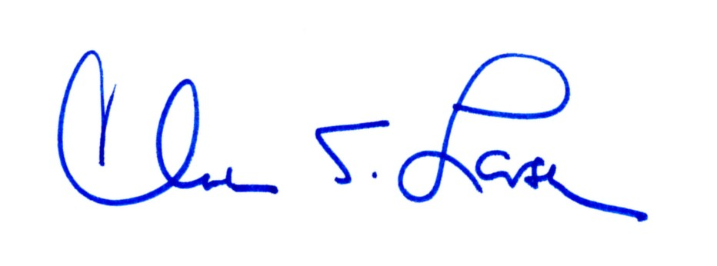
Clark Spencer Larsen
Distinguished Professor of Social and Behavioral Sciences and Chair


W. Scott McGraw
Professor and Chair, Anthropology Undergraduate Curriculum Committee

